An Automated Winch System for Underwater Sampling

MSU ECE Smart MicroSystems Lab

Final Report - Team 12
ECE 480
6 December 2019

Nick Alfano, Adam Chapman, Paul Hanvey, Yacer Mirza,
Parwesh Rallapalli, Philip Schmitz, Funakoshi Silva
Facilitator: Dr. Sunil Chakrapani
Sponsor: Dr. Xiaobo Tan

EXECUTIVE SUMMARY:

This report lays out the completed work for the Automated Winch System for Underwater Sampling Project, as directed by the MSU Smart MicroSystems Lab. The objective of this project was to develop a winch system that can lower a system to any desired depth underwater based on a user-input value and the feedback it receives from a pressure sensor. The work itself was split into four main components: power distribution, communication, controls, and component management. Energized by two 18.5V batteries in parallel, the system must distribute the power to a 12V winch, a 5-7V PixHawk controller, and a 5V Raspberry Pi. The communication aspect of the work included the constant interface between the pressure sensor and the Raspberry Pi, so that the winch could decide to alter its depth. The PixHawk’s primary role was to control the boat to certain coordinates, similar to how a drone operates. Furthermore, the PixHawk had to ensure that both the boat thrusters and winch would not be on at the same time so as to not overdraw power from the battery. Finally, the design must be constricted so that all components can fit inside a waterproof case. A solid blend of electrical, computer, and mechanical operations, the project eventually proved successful. At the conclusion of the semester, the team was able to efficiently enter a certain depth and have the winch automatically lower or raise the system to that point. All parts, additionally, were compartmentalized into the waterproof casing, making the project a success. This progress will set the foundation for future work within the Smart Microsystems Lab.

Acknowledgments

Our team would like to give our utmost appreciation to our project sponsor Dr. Tan for his support of our team. We’d also like to acknowledge Chandler Panetta for his tremendous contribution to the guidance and success of our team. He made sure we were on track with our ideas and gave us to the proper resources to lead our team to success. Many thanks to Dr. Chakrapani who also kept us on track to our goals throughout the semester. Lastly, we’d like to thank Danton Thon whose expertise was greatly beneficial to us. He was able to fix an issue we unexpectedly encountered on short notice which led us smoothly to the final project we have today.

Table of Contents
Chapter 1
Introduction ………………………………………………………………………...4
Background ………………………………………………………………………...4
Objectives …………………………………………………………………………..6
Design Specifications ……………………………………………………………....6

Chapter 2
Selecting an Approach……………………………………………………………...9
Budget ……………………………………………………………………………...9
Activity Timeline …………………………………………………………………10

Chapter 3
Power Distribution Board Design…………………………………………………..12
Winch Hardware Design and Implementation……………………………………...14
Winch Software and Interface Design Requirements ……………………………...17
Implementation of Wireless Communication………………………………………17
State Machine Design and Implementation ……………………………………......18
Graphical User Interface (GUI) Design ………………………………..…………..19
Graphical User Interface (GUI) Implementation ………………………...………...20
Sensor to Raspberry Pi Interfacing …………………………………………….….. 21
Pixhawk Design Efforts and Implementation……………………………………….21
Dronekit Simulation ………………………………………………………………. 23

Chapter 4
Test Data………………………………………………………………………….….26

Chapter 5
Final Cost ……………………………………………………………………………29
Success and Failures ………………………………………………………………...30
Suggestions for Future Work ………………………………………………………..30

Appendix 1
Technical roles, Responsibilities, and Work Accomplished…………………………32

Appendix 2
Literature and Website References…………………………………………………...39

Appendix 3
Detailed Technical Attachments……………………………………………………...40
CHAPTER 1

INTRODUCTION:

The MSU Smart MicroSystems Lab (SML), along with Dr. Xiaobo Tan, Dr. Chakrapani, and Chandler Panetta, has commissioned the Automated Winch System for Underwater Sampling project.

In this project, the team will design and develop a compact, automated winch system that can lower environmental sensors down to any desired depth based on the feedback from a pressure sensor. After thoroughly interviewing the customers, the team proposed a design that will be divided into four main modules: power distribution, communication, controls, and data cables. Each of these modules has its unique set of requirements, as voiced by the customer to ensure the design will fit future work of the SML. The main focus of the power distribution module will be to divide the 18.5V battery, such that it is distributed as four voltages to the thruster, winch, Raspberry Pi, and the PixHawk controller. The communication aspect of the project is twofold. First, the pressure sensor must be able to be commanded by the Raspberry Pi to achieve a certain depth. Next, the sensor must wirelessly transmit its exact depth in real time back to the Pi. The controller module will include use of the PixHawk to command the depth of the winch system itself. It will be in constant contact with the Raspberry Pi to monitor water depth. Additionally, there will be a failsafe mechanism on the device that will not allow both the winch and thruster to be on at the same time. Finally, the data cable portion of the project will include the application of physically increasing or decreasing the line in the winch. This module must optimize the strength of the cable, while reducing water ingress and data loss over the required distance.

Previously, autonomous surface craft (ASC) have been limited to the water surface. This project, however, when integrated with an ASC, will enable robotic sampling of three-dimensional underwater environments. The work here will expand on a recent goal of the Smart MicroSystems Lab, which is to develop a more integrated method of using mobile robots to automate fish tracking. By laying the foundation with this automated winch system, SMLwill be able to bring this objective to fruition.

A diverse mix of seven engineers, the team consists of four EE’s and three CpE’s. The power distribution and controller modules will be headed primarily by the team’s electrical engineers. The communication and data cable modules offer a mix of software and hardware engineering that will be headed by the group’s computer engineers.

BACKGROUND:

The team is working with Dr. Xiaobo Tan and the Michigan State University Electrical and Computer Engineering Smart Microsystems Laboratory (SML) to create the Automated Winch System for Underwater Sampling. SML, led by Dr. Tan, has a mission to enable smarter, smaller, integrated systems by merging advanced modeling, control and design methodologies with novel materials and fabrication processes. Research at SML focuses on electroactive polymer sensors and actuators, modeling and control of smart materials, soft robotics, bio-inspired underwater robots, and underwater mobile sensing. [1]

Many of the previous projects the Smart Microsystems Laboratory focus on robotic fish. Robotic fish are underwater robots that emulate locomotion of live fish through actuated fin and/or body movements. They are of increasing interest due to their potential applications such as aquatic environmental monitoring and robot-animal interactions. [2] One application of the research and development of robotic fish is automated fish tracking. SML has begun developing other ways to use mobile robots for automated fish tracking as well, such as using Autonomous Surface Craft.

Project lead and master’s student Chandler Panetta has been researching Time Difference of Arrival-based localization using Autonomous Surface Craft to automatically track the location of certain fish. The United States Geological Survey (USGS) implants certain fish with an acoustic tag, and underwater acoustic receivers will detect the pings from the tag. There are four receivers, which then record the time of arrival for each ping. Each receiver is at a known location and depth, and using the time of arrival at each receiver, the exact location of the fish can be determined at the time the tag sent the ping.

The current method for staging said receivers is outdated, and the team will be developing a new Automated Winch System for Underwater Sampling to assist in the research for automated fish tracking. Previous teams have created a power distribution system for the Autonomous Surface Craft. The system consisted of a 18.5V LiPo battery connected to a six-position terminal block, a PixHawk powered by a PixHawk power module, a thruster connected to an 18.5V rail using BlueRobotics electronic speed controller, and a 5V ServoRail powered by a simple buck converter. This design is illustrated in Figure 1. The current team will need to optimize this design with a power distribution board so that an electronic anchor (winch) can be added without increasing the size of the power supply.

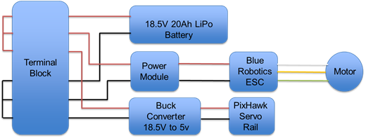
Figure 1: Previous design of power distribution system

OBJECTIVES:

The team has been given four base objectives, each is fairly complex and comes with its own list of more specific requirements. They will require time and understanding to complete them, however, the base objectives are straightforward. For the first objective, the team is tasked with designing a power distribution board that can supply power to every component on the craft. This includes powering the BlueRobotics Electronic Speed Controller and its associated BlueRobotics Thruster, the PixHawk, the Raspberry Pi and the Trac Deckhand 40 Winch. These components have varying power requirements meaning that the team will need to use circuitry that can distribute and manage power to each device correctly.

The second objective the team is faced with is communication between all devices. There are several lines of communication that need to be established based upon the requirements from the sponsor. Communication between the host computer and the PixHawk Controller, between the PixHawk and the Raspberry Pi, between the Raspberry Pi and the winch, the depth sensor, and the underwater technology that the Smart Microsystems Lab will eventually implement. This objective will be mostly handled on the programming side, however, it has a few electrical needs that must be addressed.

Moving on to the third objective, the controller. This is the link between the communication and the power. The controller will control things like the coordinates of the watercraft’s destination and the routing of power to operate the crafts thruster or winch. The controller will be responsible for a very important portion of the project and that is component and circuit protection. Due to the restrictions that come with using batteries, the team cannot exceed the maximum current capabilities of the battery without having unstable and potentially fatal implications. The controller will be responsible for operating a relay that will route current to one of the two very demanding components on the boat.

Finally, the fourth objective is a more simple objective. The team is asked to replace the rope that comes standard on the Trac Deckhand 40 Winch with a data cable that is capable of meeting the communication requirements as well as being strong enough to support its own weight as well as the sensors weight.

DESIGN SPECIFICATIONS:
Each of these four objectives, as mentioned above, has some very important design specifications that must be considered in order to successfully complete the project. Some of the basic design specifications were covered above, this section will explain more about the basic specifications as well as touch on some of the smaller details. One of the most important aspects of this project is the power distribution board. The Smart Microsystems Lab has asked the team to design and fabricate a PCB that will satisfy all power distribution needs. Specifically, the PCB needs to be small enough to fit within the Pelican waterproof case that will eventually be provided. The dimensions have not been given, however, before any PCB design is considered the measurements will be provided. Another PDB spec that is pre-determined by the project sponsor is the input and output voltages of the system. The Smart Microsystems Lab has provided the team with two 18.5V batteries that will be run in parallel and each have a maximum current draw of 20A. The board will be responsible for powering a Raspberry Pi, which takes a 5V, 2.5A input. Since the batteries provide 18.5V the PDB will require a DC to DC conversion. This will be done by implementing a buck converter within the board. The buck converter uses a switching voltage regulator along with a series of electrolytic capacitors, ceramic capacitors, resistors, an inductor and a diode to regulate voltage as needed; in this case, 5V. The same principle will be used when converting 18.5V to 12V for the Trac Deckhand 40 Winch. The winch can take up to 20A. It becomes evident that there is a current draw issue if the winch is operating at full load as well as both thrusters working at full thrust. This will be addressed shortly. The board will also power two BlueRobotics Electronic Speed Controllers (ESCs) that will control two BlueRobotics Thrusters. The ESCs can take voltage anywhere between 7-26V and draws 32A at max. Again, noting that this would exceed the abilities of the batteries if ran in conjunction with the winch. There are two methods that will be implemented to combat this. First, the thrusters will have a software stop that does not allow them to run at max power. Second, the PDB will have a relay that is controlled by the Raspberry Pi. The relay will engage only the thrusters or the winch at one moment, never allowing both components the ability to simultaneously draw current from the battey.

While there are many design specifications for the PCB Power Distribution Board, there are not as many for the other 3 objectives: Communication, Controller and Data Cable. In terms of communication, The Smart Microsystems Lab asked the team to use X-Bee to communicate with the Raspberry Pi. The Raspberry Pi will also need to be fed GPS data from the PixHawk, therefore, sufficient communication between the two modules will be very important. For the controller, it will need to maintain the operation of the relay in order to preserve the battery as well as use GPS coordinates to route the watercraft to its destination. Finally, some thought has to go into choosing the right data cable to meet the specifications set. The cable must be tested for water ingress and be strong enough to, without a doubt, pull its own weight plus all sensors.
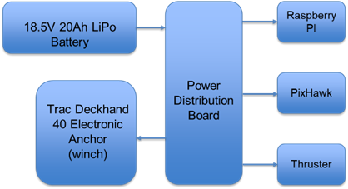

Figure 2: Proposed Design of Power Distribution Components

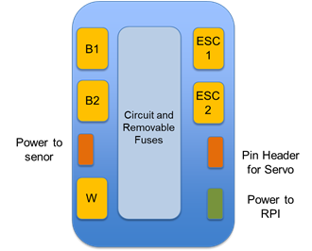
Figure 3: Proposed Layout of Power Distribution Board

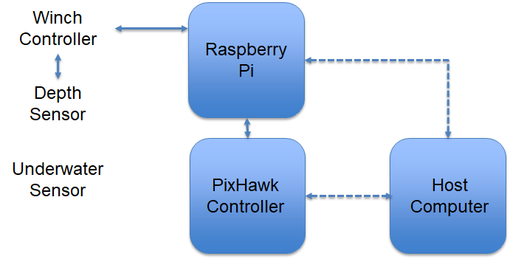
Figure 4: Proposed State Machine Flowchart

CHAPTER 2

SELECTING AN APPROACH:

The MSU Smart Microsystems Lab developed this project to aid in the collection of data in an ongoing project. Before handing the project off to the team, the SML first set their requirements. The lab required that we fit all of our electronics within a Pelican waterproof case and that the team used the winch that the SML had already purchased. This narrowed the teams possibilities in terms of coming up with a design. As a result, the team chose to pursue the approach outlined in our proposal. The team would design a power distribution board using buck converters to appropriately power every component, we would write software that would allow a user to input a location and a depth and execute those commands respectively and we would use a raspberry pi to control the winch. Each of these components is outlined in detail in the latter chapters. Over the duration of the project there were a number of small components that were overlooked in the planning stages of the project. These changes included things like, a 4 channel relay that would control the direction of the winch, a pulse width modulator to control the speed of the winch, a weight designed to pull the sensor as deep as possible and a GPS module reserved for the raspberry pi. All of these components were not anticipated but eventually their importance became apparent and the team responded accordingly.
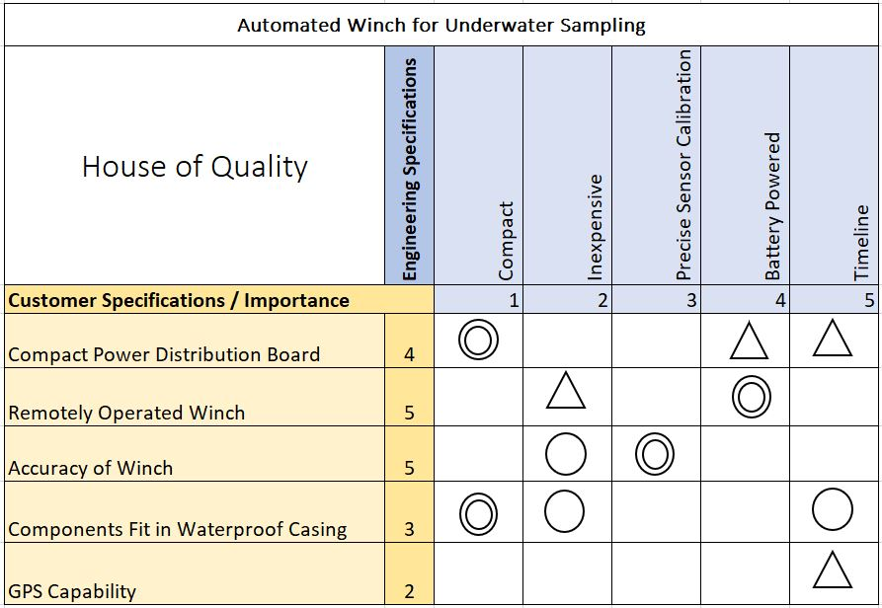
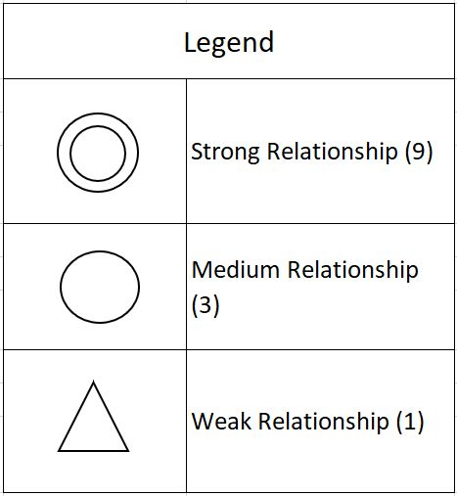

Figure 5: The house of quality chart establishes the relationship between customer needs and design application.

BUDGET:

The cost of a project is an important factor of its success. The initial budget created for our winch project was intended to be as conservative as possible to allow plenty of room for error. This cushion was critical to us because the team was dealing with the fabrication of custom printed circuit boards, expensive sensor units, and the use of delicate electronics in an aquatic setting. As shown in Figure 3, the team budgeted mostly for macro-sized components that would not be provided by the sponsor. While budgeting to the smallest component allows for a more accurate cost tracking system, it does not afford as much flexibility. When building a prototype it is often necessary to be flexible in order to make a product that still meets its end goal objectives. The initial cost of all the parts necessary to build the functioning automated winch came out to be $416.50. This estimate neglected shipping costs and any other fees that may occur. It was determined that staying under the $500 limit would be very feasible given the project mostly consisted of the integration of different subsystems.

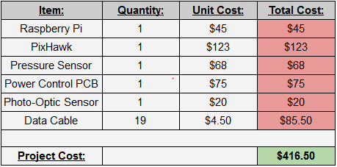
Figure 6: Budget Table

ORIGINAL GANTT CHART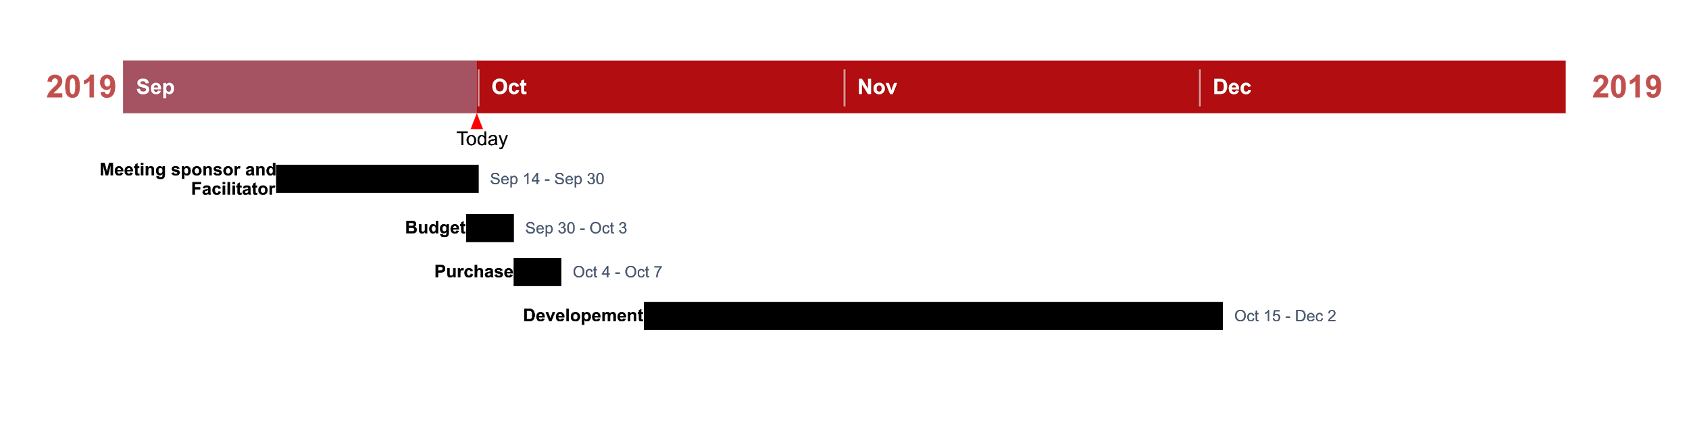

Figure 7: Initial Gantt Chart

UPDATED GANTT CHART

The Gantt chart can be found at the end of the report in Appendix 3. Below is listed the tasks scheduled for the completion of the automated winch project. The tasks were organized in a way that allowed the team to complete two of the most important milestones that refers to testing the winch prior to access to the water tank, and after access to the water tank. These two milestones were the most important because in order to complete the test without the tank most electrical components need to be installed and the software state machine needed to be completed in order to communicate to the electrical components via the raspberry pi microcontroller.The testing after access to the water tank is crucial because it allowed to notice software flaws, and electrical flaws therefore helping the team to iterate the worked done. Other reason why testing after access to the water was crucial because it allowed to gather data regarding the accuracy of the photo-optic sensor, being that crucial for the sensor calibration.Updates to the Gantt chart were made because as the project was evolving and the team started to get more knowledgeable regarding the project, new technical challenges started to be noticed, and new ideas started to be created. The new Gantt chart in comparison to the previous, presents a more detailed breakdown of the team tasks, and due dates, and a more detailed visual analysis of the completed tasks and milestones for the winch project.

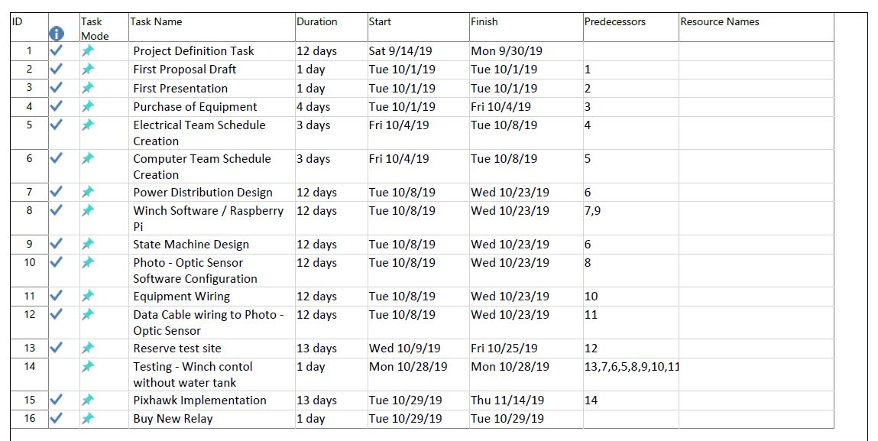
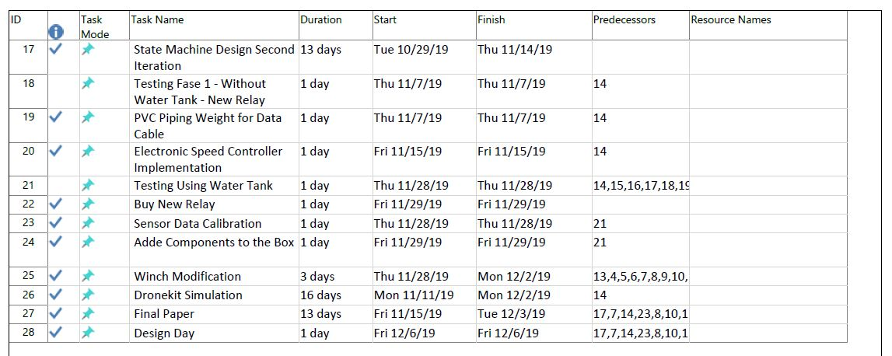
Figure 8 : Table of Tasks

Chapter 3

Technical Descriptions of Work Performed:

POWER DISTRIBUTION BOARD DESIGN AND IMPLEMENTATION

Our team was tasked with developing a power distribution board capable of distributing power to a number of devices at different voltages. To accomplish this task, the team began researching DC to DC conversion. The circuit can operate under quite high currents, therefore the team needed to consider efficiency while designing the power distribution board. Through research, the team found that buck converters would be the most balanced DC to DC converters when considering price, efficiency and area. A reliable manufacturer of DC to DC converters is Texas Instruments, they also provide a tool that uses voltage input, voltage output and current output to build a circuit using one of their integrated circuits. The team utilized this tool to create a schematic for 5 volt, 7 volt and 12 volt conversion circuits. The schematics were then reproduced in EAGLE and appropriately connected together. The schematic can be seen below in Figure 9. The team ordered the necessary components, assembled the circuit and began testing. The results of which can be found in Successes and Failures. Finally, to wrap up the design process for the power distribution board, the schematic was generated in EAGLE’s board layout tool. The board is designed as a two layer, 1.6mm, 3 inch by 3 inch, 1 oz copper board. The traces were laid out and the copper pours were generated. The final PCB design for the power distribution board can be seen in Figure 10.
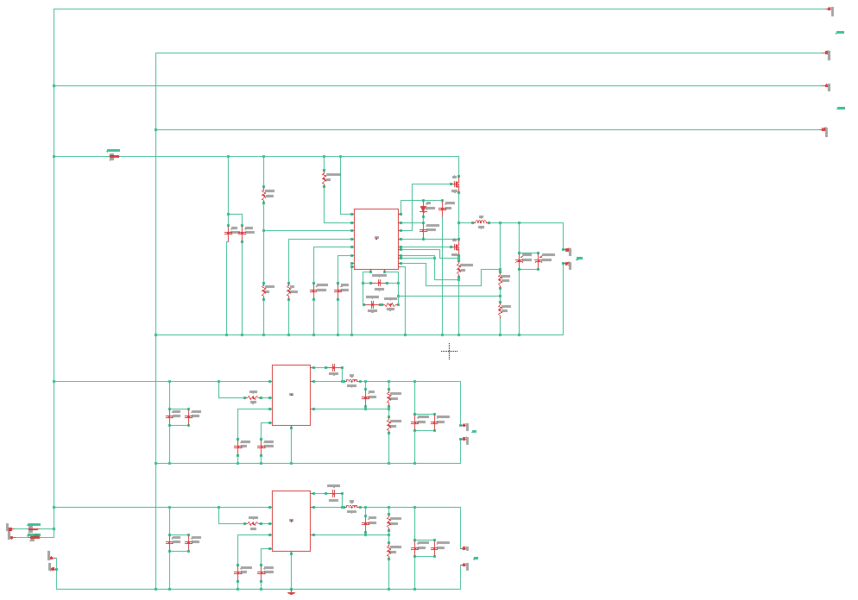
Figure 9 : Conversion Circuit
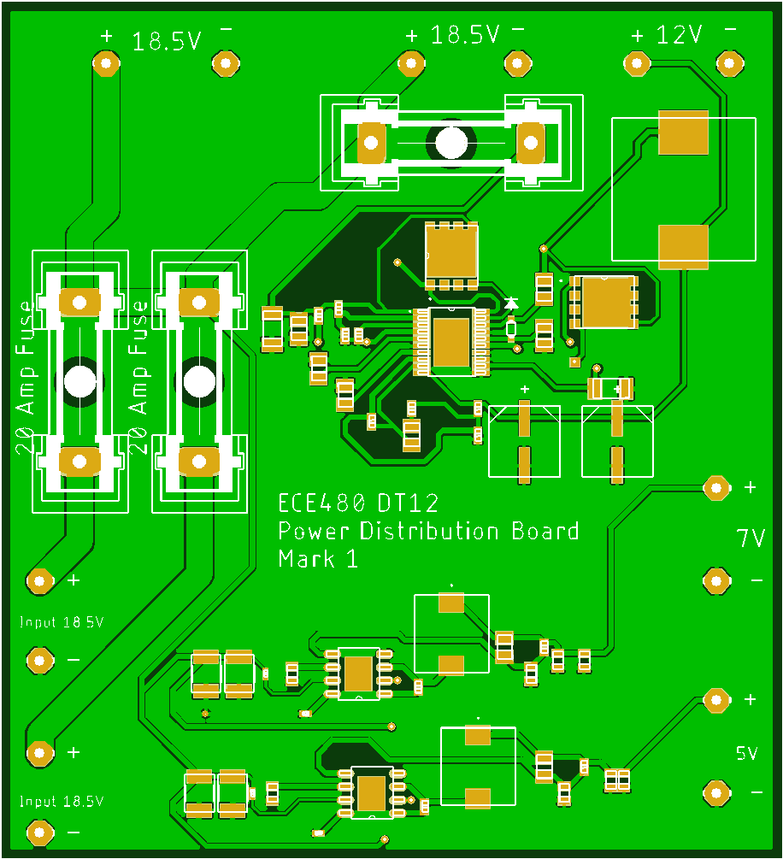
Figure 10 : PCB Power Distribution Board

WINCH HARDWARE DESIGN AND IMPLEMENTATION

The entire project revolved around the winch itself. The winch was provided by the sponsor but needed several key alterations to fit the proposed design. First, to automate the system’s mechanics the team had to do away with the physical “up,” “down”, and “off” buttons on the winch. This turned out to be one of the largest challenges of the project, as it was completely missed in the proposal. But in terms of automation it made complete and total sense to not have to physically depress any buttons on the winch. Furthermore, the system deals with relatively high current transmission, and it cannot afford any more power usage than completely necessary. After careful research, the team had determined an electronic relay was the necessary solution. A relay is simply a switch controlling a high-current circuit with a low-current signal. The first relay ordered was a two channel relay with the team believing that one channel would be needed to control “up,” and the other channel for “down.” The team happened upon this logic because they had found the following wiring scheme would result in the winch moving up: the positive terminal of the battery to the positive terminal of the motor and the negative terminal of the battery to the negative terminal of the motor. The opposite, where the winch-battery wiring goes positive (terminal)-negative and battery-winch wiring goes negative-positive, would result in the winch moving down. Therefore, the relay should be able to shift between these two states until the desired depth is achieved. Unfortunately, this method failed to take into account the third state of the winch: off. And with the two channel relay the team had already ordered, a change in hardware was needed. Fortunately, to upgrade to a four channel relay was relatively inexpensive. The new four channel relay allowed for functionality in all three commands, and once it was wired up to the battery, the obstacle had been overcome. Now, instead of the battery feeding directly to winch’s motor, the battery connects directly to a 4 channel relay and indirectly to the motor.

Another unforeseen challenge that came up with the winch was speed regulation. Previously, the winch would operate at full speed when turned on. This caused major problems with testing because the pool the team had access to was only about 4 feet deep, meaning the winch would reach the bottom in a matter of seconds; this was much too quick for the pressure sensor to interface with the Pi and, subsequently, the Pi to the winch. To overcome this challenge, another hardware implementation was necessary – this time, a speed controller. To slow down the speed of the winch, the speed controller simply uses a potentiometer to increase or decrease resistance to the motor which, in turn, decreases or increases speed, respectively. This speed controller hooks up directly to the battery to regulate resistance, and it turned out to be instrumental in the success of the project.

The final challenge to the winch was a purely mechanical problem. The spool of the winch, which was supplied by the sponsor, was not hollow and, therefore, could not reel up/down on one side while being cemented into the Raspberry Pi on the other. In other words, one end of wire cannot be spun on a spool while the other end is stationary and connected to the Raspberry Pi. To overcome this, the team decided on the implementation of a slip ring. The inside of the spool also had to be excavated with a drill press so that the data cable could snake through the very middle of the spool. This operation, paired with the slip ring, now allows for one end of the wire to spin with the winch, while the other remains firmly grounded into the Raspberry Pi. Once all these challenges had been controlled, the winch finally provided the proper functionality the team had been tasked with. Going forward, all that was left was the software synchronization with the pressure sensor and the PixHawk controller.

Figure 11: The complete winch system showing pressure sensor at one end with stationary wires (to be connected to Raspberry Pi) through the slip ring at the other.

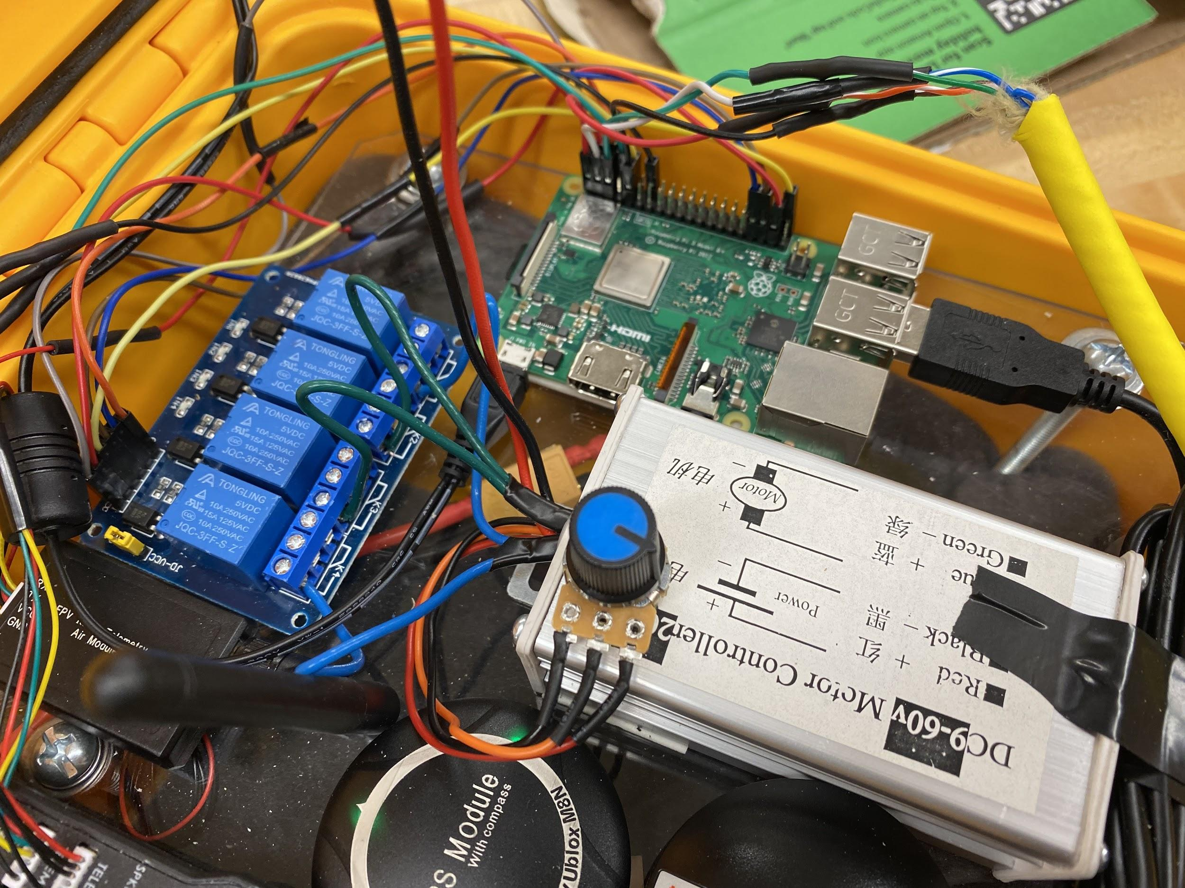
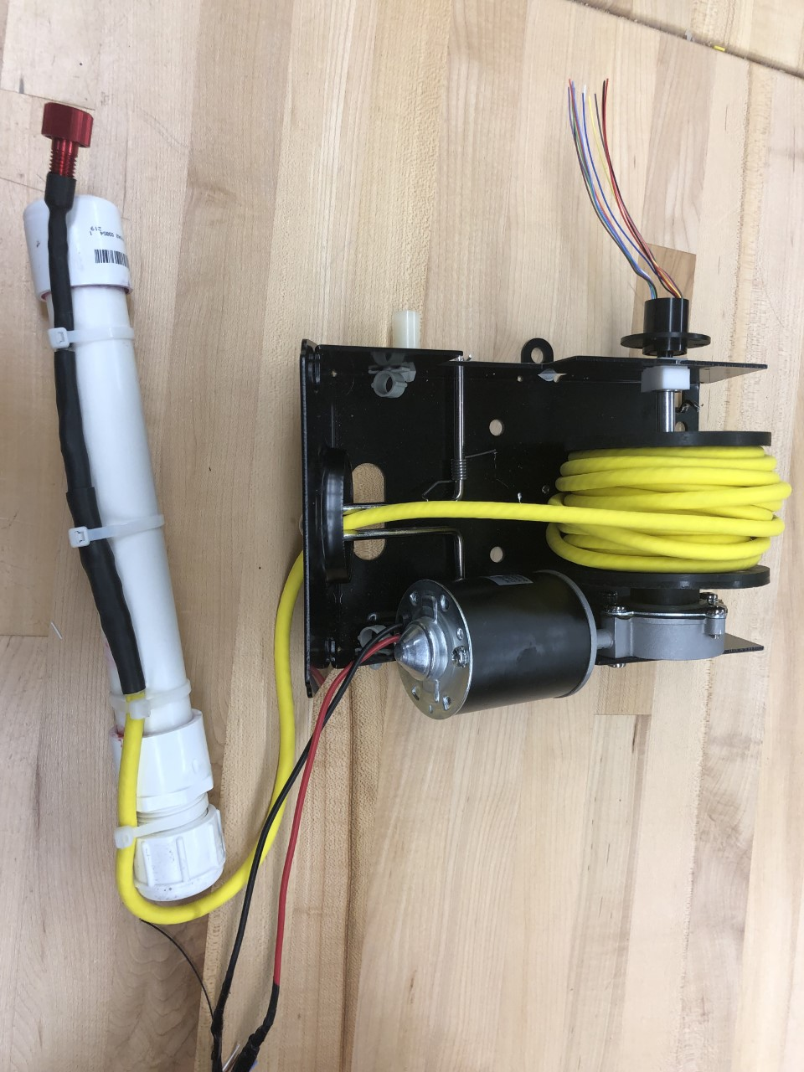
Figure 12: The electronic speed controller (right), relay(left), and Raspberry Pi (middle)

